 | POSITION DESCRIPTION FORM
File No: PDF-F0060990
POSITION IDENTIFICATION
Title: | Centre Supervisor | Level: | Level 4
Service Unit: | Eaton Recreation Centre | Award: | Local Government Industry Award 2020 Industrial Agreement
Directorate: | Community and Economic Development | Date Effective: | 10 December 2020
Reporting to: | Customer Experience Team Leader | Date Last Reviewed: | 30 July 2024

PURPOSE OF POSITION
- Ensure a high standard of customer service by overseeing and positively contributing to the effective and efficient operations of the Centre to meet our service standard ‘exceptional service, every customer, every interaction’.

- Ensure that all services contribute to an overall positive image of the Centre by providing excellent customer service.

- Provide helpful and efficient service to all internal and external customers to reflect a positive corporate image of the organisation.

SUMMARY OF ACCOUNTABILITIES & RESPONSIBILITIES
- Provide excellent service as the first point of contact for members and customers of the Centre.

- Supervise on-duty staff and the day-to-day operations of the Centre to ensure appropriate levels of service delivery to meet the Centre’s requirements and customer’s expectations.

- Perform front counter duties, café sales and food and beverage preparation.

- Oversee and assist with events hosted by outside individuals, organisations and groups ensuring the centre is satisfying its provision/delivery requirements.

- Ensure correct banking procedure are followed and any discrepancy procedures are adhered to.

- Undertake daily open and close activities as per Eaton Recreation Centre procedures.

- Respond to customer feedback enquiries in-line with Council’s adopted Customer Service Charter.

- Ensure sporting competition is maintained to a high standard, including oversight of umpires/referees.

- Ensure that equipment and facilities are clean, hygienic and safe to use as per Eaton Recreation Centre procedures.

- Undertake on the job and off the job training as required to maintain qualifications and industry knowledge.

- Any other duties as directed by the line supervisor / manager.

ORGANISATIONAL RELATIONSHIPS
Responsible for: | Eaton Recreation Centre employees as required.
Internal Relationships: | All Shire of Dardanup employees and Elected Members.
External Relationships: | Federal and State government agencies, other local government authorities, community groups and organisations, private sector stakeholders, ratepayers, members and general public.

POSITION DIMENSIONS
Work Location: | Eaton Recreation Centre.
Delegated Authority: | Not Applicable at this level.
Driving Requirements: | Not Applicable.

EXTENT OF AUTHORITY
This position operates under the direction of the Customer Experience Team Leader and under supervision either individually or in a team environment, within established guidelines, procedures and policies of Council as well as statutory provisions of the Local Government Act and other legislation.

CORPORATE ACCOUNTABILITIES
- All employees are bound by the requirements of the Local Government Act 1995 to act with integrity, and in a way that shows a proper concern for the public interest.

- Comply with Council’s Code of Conduct, management directives and approved policies and procedures.

- Avoid participation in any activities that may represent a conflict of interest with Council transactions and your obligations.

- Maintain obligations described within the Shire’s Customer Service Charter.

- Comply with all requirements for capturing corporate information and understand that the Local Government is the owner of all Intellectual Property rights in all documents, materials or other things created or contributed to by the Employee (whether alone or with others) in the course of their employment.

- Exercise discretion and maintain confidentiality in dealing with sensitive and high-level issues.

- Deliver effective use of Shire resources within the level of accountability for this position.

- Ensure your own safety and health at work by undertaking your work duties in a safe and proficient manner. Exercise your duty of care by having thought and regard for others by ensuring that you avoid adversely affecting, the safety or health of any other individual through any of your acts or omissions at work as per Council’s WHS policies and Work Health and Safety legislation.

- Employees shall cooperate with the Shire of Dardanup in the carrying out of the obligations imposed on the Shire under Work Health and Safety legislation.

- Monitor work practices, support training and engage with staff and contractors to ensure their ongoing safety and compliance with Work Health and Safety legislation, and Council’s WHS policies.
- Provide an ongoing commitment to risk, emergency management and business continuity principles.

- Employees shall demonstrate the Shire’s Values “Trust, Respect, Accountability, Customer/Community, Excellence and Support” within the workplace.

VALUES
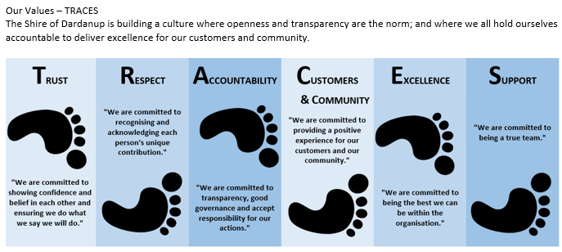

SELECTION CRITERIA
Essential: | - WACE or equivalent; additional education or training in leadership is a plus.  - Previous experience in supervising a team and an ability to apply hands on approach to work to achieve outcomes.  - Excellent verbal and written communication skills and conflict management to be able to communicate clearly and concisely to a broad range of stakeholders.  - Strong computer skills, the ability to adapt to new technology and processes quickly and troubleshoot and train others on systems.  - Current Provide First Aid, CPR, Working with Children check and National Police Clearance.
Desirable: | - Previous experience in local government operated recreation facility or similar.  - Experience in the use of leisure management and point of sale systems.  - Accurate cash handling and receipting of monies with experience reconciling daily takings and banking.

SIGNED:
 | Present Occupant: | Noverose Cabillan
 | Signature: |  | Date Signed:
 | Supervisor: | Customer Experience Team Leader | Date Issued: | 15/07/2026
 | Approved by: | Director Community and Economic Development | Date Approved: | 8/08/2024
 | Director Signature: |  | Date Signed:
 | Reviewed by: | Human Resources | Date: | 8/08/2024

